Peanut Butter Delights

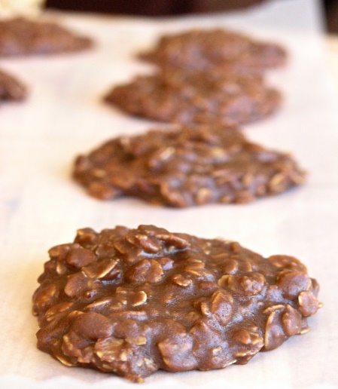

Ingredients

* 2 cups granulated white sugar
* 5 tablespoons unsweetened cocoa
* 1 stick butter
* ½ cup milk (you can use evaporated milk)
* ½ cup creamy peanut butter
* 1 teaspoon vanilla
* 3 cups Old Fashioned Quaker Oats

Directions

1. In a medium saucepan stir add the sugar, cocoa, butter and milk.
2. Over medium-high heat, bring it to a boil, stirring to help the butter melt. Boiling means that there are bubbles all the way across the top of the liquid. Start your stopwatch now and boil it for exactly 1 minute.
3. Remove from heat and quickly add the peanut butter, vanilla and oatmeal and stir to combine.
4. Working quickly, drop spoonfuls of the mixture onto a sheet of waxed paper. They will cool and harden within a few minutes. Voila. You're done!